Repeat yesterdays lab

Add Pixel 2 with Noughat (version 7.1.1)

LifeCycle Method Testing

Create a android project name it first

Add the following code to activity_main.xml

*<?*xml version="1.0" encoding="utf-8"*?>*<androidx.constraintlayout.widget.ConstraintLayout xmlns:android="http://schemas.android.com/apk/res/android"  
 xmlns:app="http://schemas.android.com/apk/res-auto"  
 xmlns:tools="http://schemas.android.com/tools"  
 android:layout_width="match_parent"  
 android:layout_height="match_parent"  
 tools:context=".MainActivity">

<TextView

android:id="@+id/text"

android:layout_width="wrap_content"

android:layout_height="wrap_content"

android:text="Watch the Log in Android Studio when you run the application"

app:layout_constraintBottom_toBottomOf="parent"

app:layout_constraintLeft_toLeftOf="parent"

app:layout_constraintRight_toRightOf="parent"

app:layout_constraintTop_toTopOf="parent"

app:layout_constraintVertical_bias="0.056" />

<Button

android:layout_width="match_parent"

android:layout_height="wrap_content"

android:layout_marginTop="52dp"

android:layout_marginEnd="50dp"

android:layout_marginStart="50dp"

android:layout_weight="50"

android:onClick="gotoActivity2"

android:text="go to Activity2"

app:layout_constraintTop_toBottomOf="@+id/text"

tools:layout_editor_absoluteX="15dp" />

</androidx.constraintlayout.widget.ConstraintLayout>

Add the following code to MainActivuty.java

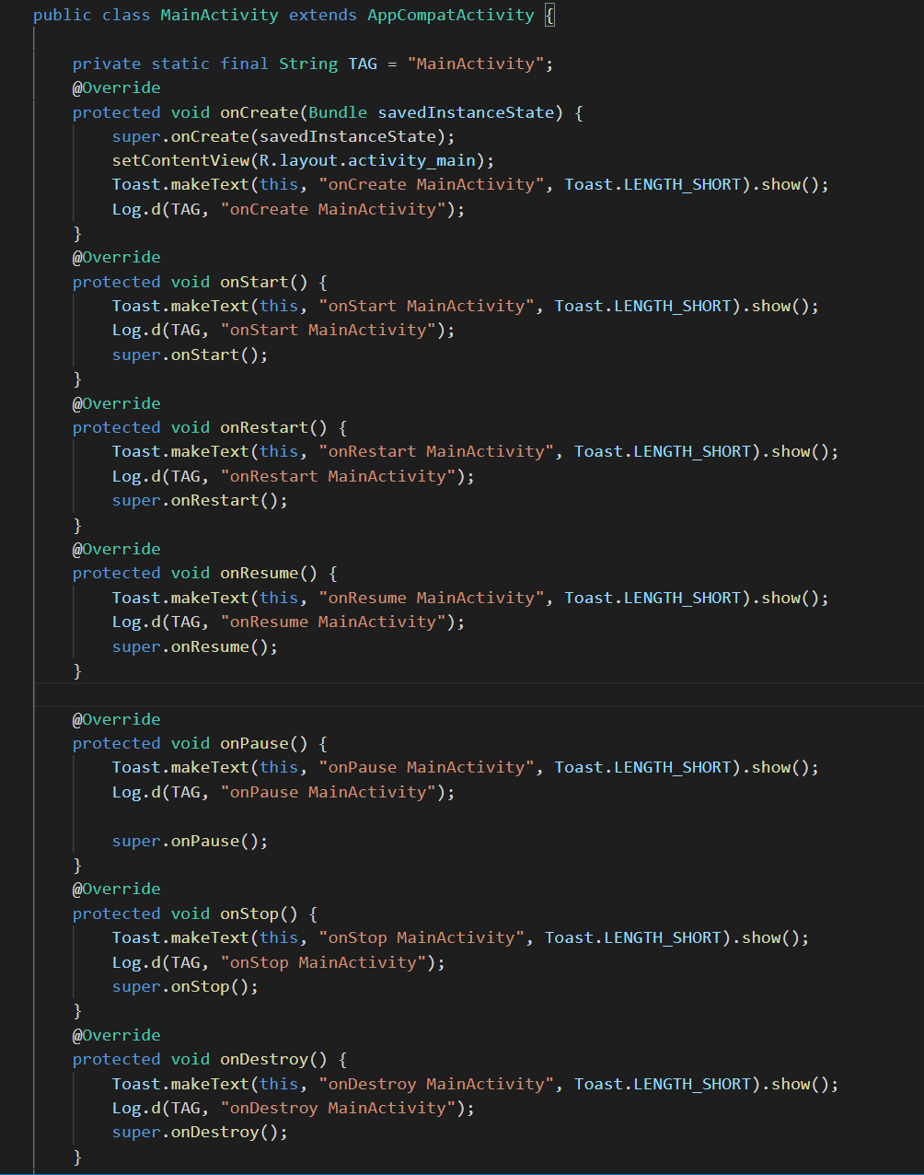

Test it